**STATS 531 HW10**

Xiaoyue (Platina) Liu 28589009 [xiaoyliu@umich.edu](mailto:xiaoyliu@umich.edu)

My dataset is the blowflies data provided on the github.

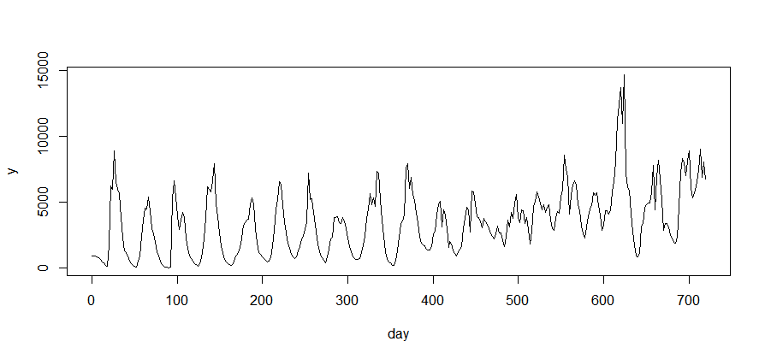

I would like to use the simple Ricker model for the blowfly population. Then modify the model to more complex Hassel model and Beverton–Holt model for analysis.

Then I will compare my model with a partial reproduced model given from the literature: Wood, S. (2010), “Statistical inference for noisy nonlinear ecological dynamic systems”, Nature 466:1102–1104.

Finally I will do some likelihood-based inference and simulation using particle-filter and the likelihood surface.

I am not good at POMP models and having some difficulty with Windows, too. I will find a way out. Could you please give some instructions on the topic I chose here？